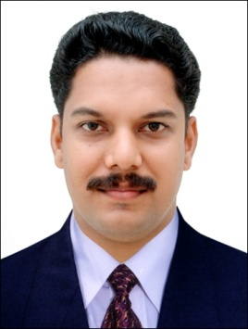 | Name | Lt. Prageesh C. Mathew
 | Designation | Assistant Professor
 | Qualification | M.Com., M.Ed., MBA., M.Sc. (Psy.), PGDHRM

Qualifications: B. Ed. with highest mark in the faculty of commerce
NET in Education, NET in Commerce,
Post Graduation in Psychology with specialization in counselling
M. Ed with specialization in Commerce Education
Certified trainer of Junior Chamber International

Publications: An empirical analysis on Cognitive Resonance: Trade wind; ISSN 2320-5393

Corporate Life:
NCC officer : 2012 onwards
Placement Officer : 2012 onwards
Counselling Centre : 2012 onwards
Ethics Committee : 2013 onwards
Liaison with DD office : 2012 onwards
IQAC Member : 2014 onwards
Arts Club : 2012 onwards
Alumni Association : 2012 onwards
Travel facilities to students : 2012 onwards
UGC NET Coaching : 2012 onwards
Executive committee member of the college exhibition : 2012
(Newman Expo2012)
Executive Member of Golden Jubilee celebration : 2014-15
Bank Coaching : 2013 onwards
Employment information cell : 2013 onwards
Blood Donors Forum : 2013 onwards
Human Resource Development Centre : 2015 onwards
Share a bread scheme initiated by Newman College : 2015 onwards

JCI Trainer who conducted more than 500 training programmes for Parents, Teachers and Youth in the area of Human Resource Development

