POST GRADUATE DEPARTMENT OF ECONOMICS, NEWMAN COLLEGE, THODUPUZHA
QUALITY PROFILE 2016-2017
LEAD KINDLY LIGHT
POST GRADUATE DEPARTMENT OF ECONOMICS
NEWMAN COLLEGE, THODUPUZHA
PROFILE
The Department of Economics was established in the year 1967 with BA Degree course in Economics. The first batch of BA Economics came out in 1970. In 2013 the department started its post graduate programme. The first batch of MA Economics came out in 2015. The department always strives hard to achieve the lofty ideals envisioned by the founding fathers of the college and beloved former faculty members of the department.
Department at a Glance....
- Established in the year 1967 with BA Economics
- Elevated into Post Graduate Department in 2013
- First BA batch came out in 1970 and MA in 2015
- 230 students and 7 teaching faculty at present
Major highlights….
- National Seminars
- Mentoring
- Remedial Coaching
- Community Development Programmes
- Newman Economic Forum (NEF)
- Budget Analysis
- Powerful Alumni Association
- Invited Talks

1(A). FACULTY PROFILE –POST GRADUATE DEPARTMENT OF ECONOMICS (2016-17)
Faculty | Designation | Qualification | Teaching Experience | Subject Engaged
Dr.Celinekutty Mathew | Asso.Prof. &Head | M.A, M.Phil.Ph.D. | 20years | Research Methodology
Mr. JenniK.Alex | Asst.Prof. (on FIP Leave ) | M.A, B.Ed., NET | 8 Years | Macro Economics
Mr.XavierKurian P | Asst.Prof. | M.A, B.Ed., NET | 4 years | Development Economics
Mr.Ratheesh E R | FIP  Substitute | M.A, B.Ed., NET | 3years | Public Finance
Mrs. Rosemary Varghese | Asst.Prof. on contract | M.A, B.Ed., NET | 4 Years | Micro Economics
Ms. JipsyMol V. Jimmy | Asst.Prof. on Contract | M.A, NET | 2 year | Quantitative Economics
Mr. Beetu Sebastian | Asst.Prof. on Contract | M.A | 1.3year | Indian Economy
Ms. Jinu Jose | Asst.Prof. on Contract | M.A, B.Ed. | 8 Months | Monetary Economics

- STUDENT PROFILE 2016-2017
The admission process is based on merit with mandatory reservation for the deserving categories. Fifty per cent of the total seat is filled by the University under the general merit quota through Centralized Allotment Process. The merit is decided on the basis of marks scored in the respective qualifying examinations; namely higher secondary and degree. The quota is available to SC/ST/OBC/OEC and physically challenged candidates. A small proportion of the seats are filled under management quota where candidates from disadvantaged sections of the society and differently able candidates are given priority. Here too, admission is on the basis of merit
- STUDENT PROFILE 2009-2015 AT A GLANCE

B.A. ECONOMICS M.A. ECONOMICS
Year | Students  Admitted | Male | Female |  | Year | Students  Admitted | Male | Female
2009 | 58 | 25 | 33 |  | 2013 | 15 | 3 | 12
2010 | 58 | 27 | 31 |  | 2014 | 18 | 6 | 12
2011 | 60 | 22 | 38 |  | 2015 | 16 | 2 | 14
2015 | 64 | 21 | 43 |  | 2016 13 3 10
2013 | 68 | 20 | 48
2014 | 70 | 27 | 43
2015 | 64 | 21 | 43
2016 | 60 | 24 | 36

3(A).UNIVERSITY EXAM RESULTS OVER THE YEARS AT A GLANCE
Programme | Year | No. of Students appeared | No. of students passed | % of pass | ‘A’ grade | ‘B’ grade | ‘C’ grade | Remarks
B.A. Economics | 2010 | 55 | 51 | 92.73 | 13 | 22 | 16
 | 2011 | 60 | 41 | 68.3 | 5 | 10 | 26
 | 2012 | 48 | 46 | 95.83 |  | 20 | 31
 | 2013 | 48 | 44 | 91.66 |  | 20 | 24
 | 2014 | 55 | 48 | 87.2 |  | 17 | 32
 | 2015 | 59 | 54 | 91.5 |  | 27 | 27
 | 2016 | 56 | 21 | 37.5
3(B) .UNIVERSITY EXAM RESULTS OVER THE YEARS AT A GLANCE
Programme | Year | No. of Students appeared | No. of students passed | % of pass | ‘A+’ grade | ‘A Grade | ‘B+ grade | B Grade | C+ Grade | C Grade | D Grade
M.A.Economics | 2015  2016 | 13  18 | 8 | 62 | NIL | NIL | 6 | 2 | NIL | NIL | NIL
4. REPRESENTATION IN ACADEMIC AND NON ACADEMIC BODIES
Faculty | Representation
Mr. Jenni K. Alex | Expert Committee Member ,PG Board of Studies, M G University, Kottayam
Mr. Jenni K. Alex | Expert Committee Member ,UG Board of Studies, M G University, Kottayam
Mr. Xavier Kurian P | Member, Vigilance Squad, M G University, Kottayam

- ACHIEVEMENTS AND CREDENTIALS OF THE FACULTY:

- Dr. Celinkutty Mathew Associate Professor and Head of the Department of Economics attended AICHE(All India Association for Christian Higher Education), training programme for Christian College teachers held at American College, Madurai from 7-11 November 2017.

- Dr. Celinkutty Mathew, Associate Professor & Head of the Department of Economics attended Regional Meet2016 of the Xavier Board of Higher Education in India, (Kerala North Region) held at Nirmala College, Muvattupuzha on 15th October 2016.

- Mr. Xavier Kurian P, Assistant Professor, participated and presented a paper in the Three Day National Seminar on “Primary Health Centres and Human Capital Development: An Analysis” , organized by the Department of Economics, Government College Kattappana from 19-21 January 2017.

- Mr. Ratheesh E R, FIP Substitute Lecturer, has participated and presented a paper in the Three Day National Seminar on “Financial Inclusion and the Marginalised” organized by the Department of Economics, Government College Kattappana during 19-21 January 2017.

- Mr. Ratheesh E R, Mrs. Rosemary Varghese and Ms. Jipsy Mol V Jimmy have attended The Special Ttraining Programme for SSP Resource Persons, held at Nirmala College, Muvattupuzha on 14th January 2017.

6. ORIENTATION / REFRESHER COURSE ATTENDED BY THE FACULTY
Faculty | Orientation/Refresher course | Organizing institution | Date
Xavier Kurian P | Orientation course | HRDC, University of Calicut

7. PAPER PRESENTATIONS OF THE FACULTY (2016-2017)
Faculty | International level | National level | State level
Mr. Xavier Kurian P |  | 2
Mr. Ratheesh E R |  | 2
Mrs.Rosemary Varghese |  | 1

8. TEACHERS WHO HAVE BENEFITED FROM THE FACULTY
DEVELOPMENT PROGRAMMES.

Faculty | Seminar/Conference/Symposia |  |  | Workshops | Refresher Course/ orientation course
 | State | National | International
Dr. Celinkutty Mathew |  | 1
Mr. Xavier Kurian P |  | 5 | 1 |  | 1
Mr. Ratheesh E R |  | 2 |  | 1
Mrs. Rosemary Varghese |  | 2 |  | 1
Ms. Jipsymol V Jimmy |  |  |  | 1

9. ACADEMIC PROGRAMMES ORGANISED AT A GLANCE (2016-2017)
The Departments of Economics organized a number of academic programmes during the academic year 2016-2017.

Events | International / National level | State level | Regional | Total
Budget Analysis | - | - | 1 | 1
Workshops | - | - | 2 | 2
Invited Talk | 1 | - | 1 | 2
Total | 1 | - | 4 | 5

10. SEMINARS/WORKSHOPS/INVITED TALKS ORGANIZED BY THE

Sl. No. | Title of the Programme | Date
 | One day Workshop on the Online Trade Practices of the Capital Market | 30th August 2016
 | Lecture on Goods and Service Tax in India | 3rd November 2016
 | One day orientation class on SPSS (Statistical Package for Social Sciences) | 15th November 2016
 | Invited Lecture on “Globalisation and Challenges in Agriculture” | 23rd November 2016
 | Union Budget 2017-18 : Analysis and Discussion | 13th February 2017
 | Life Guidance seminar on the topic”Making the Right Choices” | 16th February 2017
DEPARTMENT (2016-2017)

11. FACULTY INVITED AS RESOURCE PERSONS IN WORKSHOPS/ SEMINARS /CONFERENCES
Faculty | Type of event | Venue | Date
Sri. Xavier Kurian P | Invited Lecture | Govt. College, Kattappana
Ratheesh E R | Invited Lecture | Govt. College, Kattappana

12. TEACHER QUALITY
Faculty | Area of research | Remarks
Dr. Celinkutty Mathew | Macroeconomics
Mr. Jenni K. Alex | Ecotourism | On FIP at MG University , Kottyam
Mr. Xavier Kurien P | Environmental Economics | Part time Ph.D. research scholar

13. LEARNING RESOURCES OF THE DEPARTMENT
1) 1761books in the central library 2) 11 journals in the central library.
3) 1Computer 4) 1Printer 5) UPS 6) LCD Projector
14. METHODS PRACTISED IN TEACHING
- High speed broadband facility
- ICT enabled teaching
- Class room Discussions
- Web assisted assignments
- Seminars, Workshops and Assignments
- Invited talks
- Remedial teaching
15. PARTICIPATION OF STUDENTS IN PROGRAMMES OFFERED BY
THE COLLEGE
Programmes | No. of students
Walk With Scholar
Additional Skill Acquisition Programme (ASAP)
Student Support Programme(SSP)
National Cadet Corps(NCC)
National Students Scheme(NSS)
Diploma in Computer Application(DCA)

16. STUDENT SUPPORT PROGRAMMS
- Mentoring
- Tutorial System
- Remedial Coaching
- Student Counseling
17. SCHOLARSHIPS INSTITUTED BY THE DEPARTMENT

Endowment | Sponsor
A.S. Gafoor memorial award for Top scorer in B.A. Economics (Upto IV Sem) | Alumni
Rony M. Joshy memorial award for Top scorer in B.A. Economics (Final Year) | Family of Sri.Rony M. Joshy
Eldhose Memorial Award for Top scorer in B.A. Economics | Alumni

18. INVITED LECTURE
Prof. Michel Villette from Agro Paris Tech College, Paris, presented an invited Lecture on “Globalization and Challenges in Agriculture” for Staff and students of Post Graduate Department of Economics on 23rd November 2016 at the Punnakkottil Hall, Newman College
19. NEWMAN ECONOMIC FORUM (NEF)
In 2013, the Department of Economics started an innovative programme known as Newman Economic Forum. Under this banner, the Department conducts various programmes like Debates, Quiz Competition, Essay Writing Competition, Career Orientation Programmes, Seminars, Workshops Etc. An Executive body of three student members as President, Secretary and Vice-President was formed for coordinating activities of NEF for Academic Year 2016-2017
Inaugural ceremony the activities of NEF (Newman Economic Forum) for the academic year 2016-17was carried out by Prof. K K John, Head Department of Economics, Saintgits college of Management, Kottayam on 3rd November 2016 in the function organize in the Newman College, Auditorium. Inaugural Ceremony was followed by an enlightening lecture on GST (Goods and Service Tax) in India.
20. STUDENT ACHIEVEMENTS
A number of students in the department participate in various levels of sports and arts items. Most of them achieved a number of prizes. The department also encourages its students for their active involvement in extracurricular activities. Many of our students have bagged several prizes at National, State and intercollegiate levels.

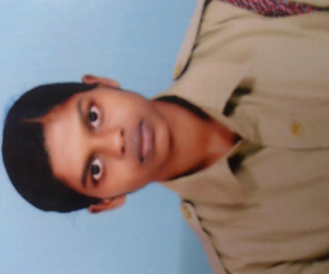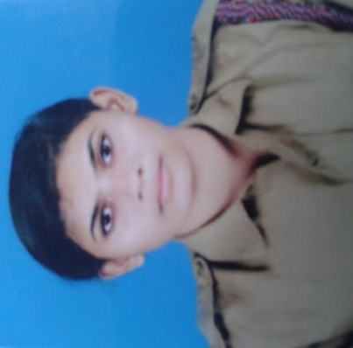
Aswathy rajesh
2014-2017 Batch
RDC Delhi (2016)
Akhila Unni, 2014-2017 batch
TSC Delhi

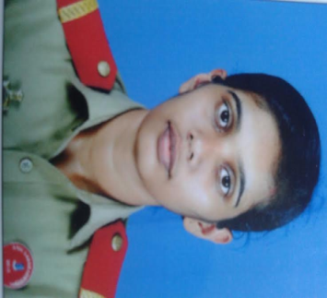
Gopika Rajesh
2013-2016 Batch
SNIC Lakshadweep

21. COMMUNITY DEVELOPMENT
As part of the community development programme, the staff and students of the department join their hands together in extending their whole hearted support in providing food packets (LUNCH) to the mentally retarded inmates of the Providence Home run by Little Sisters of Divine Providence at Ezhumuttom. The staff and students of the Department visit the home with collected food packets and spend their time with inmates of home on every first Friday of the month. Medical Aid Fund Programme which was started in 2014 to provide the financial support to the economically backward students and their families is also an another initiative of the department
. 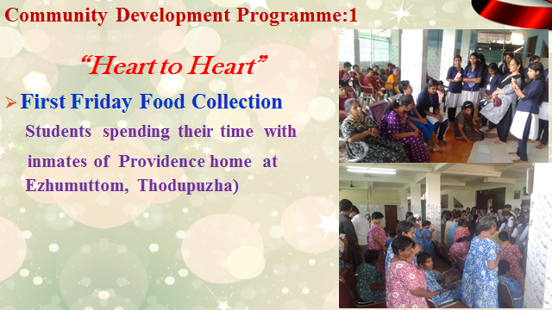
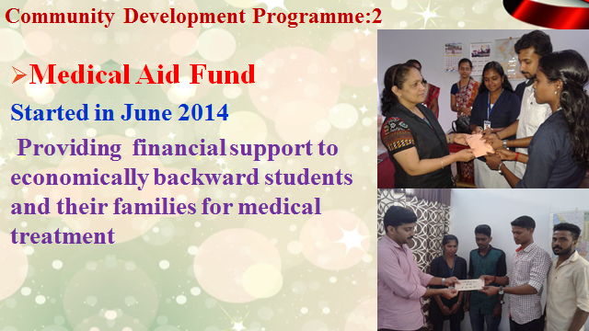

22. EXTENSION/OUTREACH ACTIVITY
The Extension and Outreach Activity division of the Department named as “PATH” is a track specially constructed for students to move ahead with Prayer & Passion, Awareness, Transformed to Help & Heal each other and others around them with Social Commitment. Under “PATH “platform Department conducted several programmes like:
- Social Commitment.
As part of the Christmas Celebration of the Department of Economics, Students & Staff Visited the Mother and Child Foundation at Painkulam on 17 December 2016 and extended financial support(Rs. 2000.00) for marginalized children and orphans in the centre. Also distributed stationary items (Rs. 2000.000) to the inmates of the institution.

- Deaddiction Centre Visit
To educate teenagers and generate awareness on the potential dangers of Smoking, Alchoholism, Drug Addiction, students and staff of Economics visited the De-Addiction Centre at Mylakombu . Students learned about the negative impacts on the health and personal development of such social evils. Also this visit gave awareness on the evil effects such as increasing violence in families, college campuses and society.

- Visiting Mentally Sick
Students & Staff visited the inmates of Mylacombu Divyarakshalayam at Painkulam on 17 December 2016 and shared some time with the inmates and gave the inmates great emotional support and happiness. Students have expressed their commitment to visit the centre at least once in a month to continue support.

- Industrial Visit.
An industrial visit Staff and Students to the Tea Factory at Ootty on 19-11-2016 provided great Industrial Experience for the final year PG students of Economics.

- HEAL
HEAL is an innovative programme of the Department of Economics at Newman College which is specially constructed for student’s mental, emotional and spiritual well-being & development. The initiatives under this platform included:
- Counseling cell in the Department & College Student Counseling Department
- Weekly Thursday prayer meet for catholic students
- Mentoring
- Charity box collection in each class to help the poor
- Retreat for students
- Life Guidance Programs for Final Year Students
Four students were participated in a programme “REVIVE” on 07/01/17

23. ALUMNI ASSOCIATION
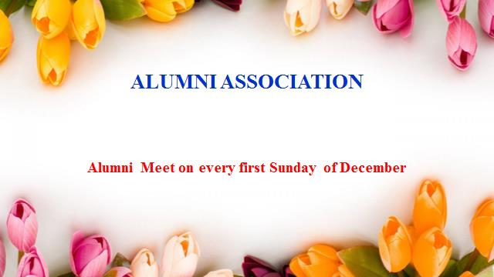
Alumni association of the department organises several programmes like carrer guidance classes, motivation classes for the students. It has instituted an endowment award (Eldhose Memorial) for the bestoutgoing degree studentof the department.

