World Ozone Day Observance - 2017
Department of Botany and Zoology jointly organized various activities in connection with World Ozone Day Observance - 2017 with the support of Kerala State Council for Science Technology and Environment.
- Seminar on Man and Nature - Five Narrations on September 26, 2017
Resource person: Dr. T. V. Sajeev, Senior Scientist, Department of Forest Entomology, KFRI, Peechi.

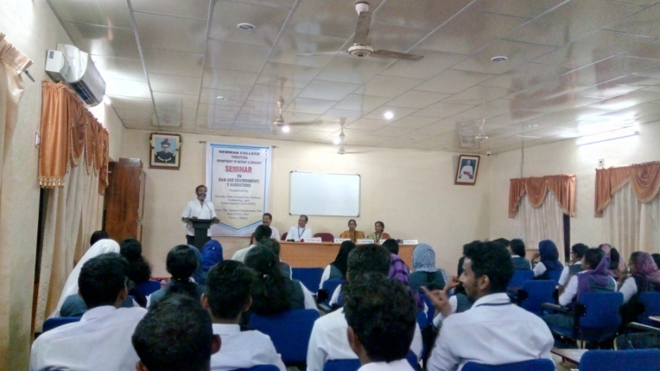

- Elocution and Painting Competition for High School Studentson September23, 2017

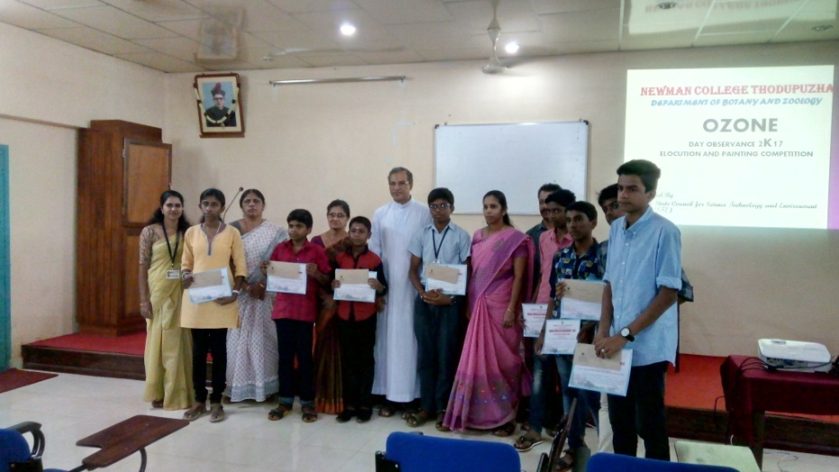

- Seminar on Caring for all life under the sunonSeptember 28, 2017
Resource person: Dr. Shaju Thomas, Head, Division of Environment Education and Conservation, Tropical Institute of Ecological Sciences, Kottayam.

