World Environment Day Celebrations – 2017
World Environment Day was celebrated by the Department of Botany, Newman College, Thodupuzha with the support of Kerala State Council for Science, Technology and Environment (KSCSTE). Various activities have been organized duringthecelebrations to fulfill the theme of this year - ‘connecting people to nature’. The activities were held in different sessions which included seminars general activities like cleaning, distribution and planting of saplings, Photo exhibition on ‘Endangered Plants of Kerala’ and a Quiz Competition for High School students.
- On World Environment Day, June 5, the department Botany tookthe initiative of cleaning thecampus and premises for creating healthyworking environment. This was also intended to encourage students to make their nearby surroundings safe and clean so as to enjoy safer, cleaner and more prosperous future.
- Seminar on‘Harmonizing Nature with Mankind- Kerala scenario’
In the afternoon session, a seminar on ‘Harmonizing Nature with Mankind- Kerala scenario’was conducted to create awareness among students about the need to understand the endless delight of nature and the imperativeof preserving it for future generations. Ms. Sindhu Rachel Joy, coordinator of the programme welcomed the gathering. Dr. Leena John, Head of the Department of Botany,in her presidential address briefed about the need of reconnecting people with nature in the present scenario of technological advances.Principal Rev. Dr. Vincent Joseph delivered the inaugural address.He appreciated the staff members for their efforts in imparting environmental awareness among students.He also advised the students to undertake ecofriendly initiatives such as establishing organic vegetable gardens at home. Dr. Giji K. Joseph, Assistant Professor, Dept. of Zoology, Nirmala College, Muvattupuzha was the keynote speaker. Being a person having several years of practical experience with nature and wild life as research fellow, he shared his lustrous field experience with students through his presentation. He added that environment daymakes a call to the people to join the celebrations in mass number to get aware of the realenvironment conditions and be an active agent of the programs against environmental issues.In the open discussion, the participants shared their views on environment preservation. They decided to contribute towards preservation of environment by changing their habits by means of, reducing food waste, saving water,saving energy at home and classrooms by switching of lights and fans when not in use, using water efficientlyand substitution of plastic bags with cloth and paper bags. The meeting concluded with the vote of thanks of Krishna Haridas final year BSc Botany student.
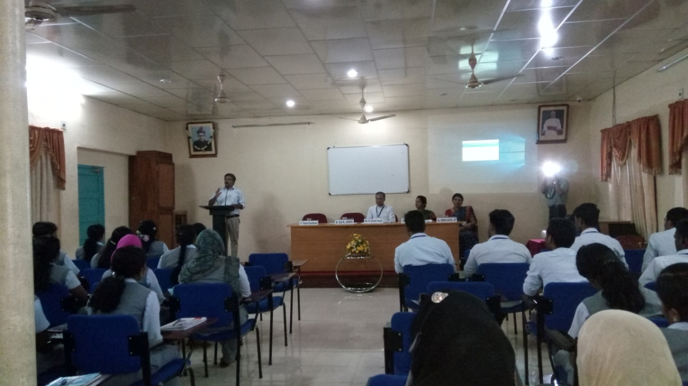

- Distribution of Saplings:
Official inauguration of the distribution of sapling to students was done by Principal Rev. Dr. Vincent Joseph, on 6 June 2017. In his inaugural address, he pointed out that the condition of our environmentis getting deteriorated day by day because of pollution and global warming. He added that youth of the country areinspiring hope to bring some positive changes in the environment. We should keep in mindthatthe objectives of this campaign throughout the year and actions accordingly in the form of beautifying the surrounding areas through plantation and cleanliness, recycling initiatives, less use of electricity, using organic foods, and saving natural resources should motivate and inspire people. Saplings of local trees and flowering plants like Neem, Cassia, Terminalia,Pongamia, Ficus etc. were distributed to the students.
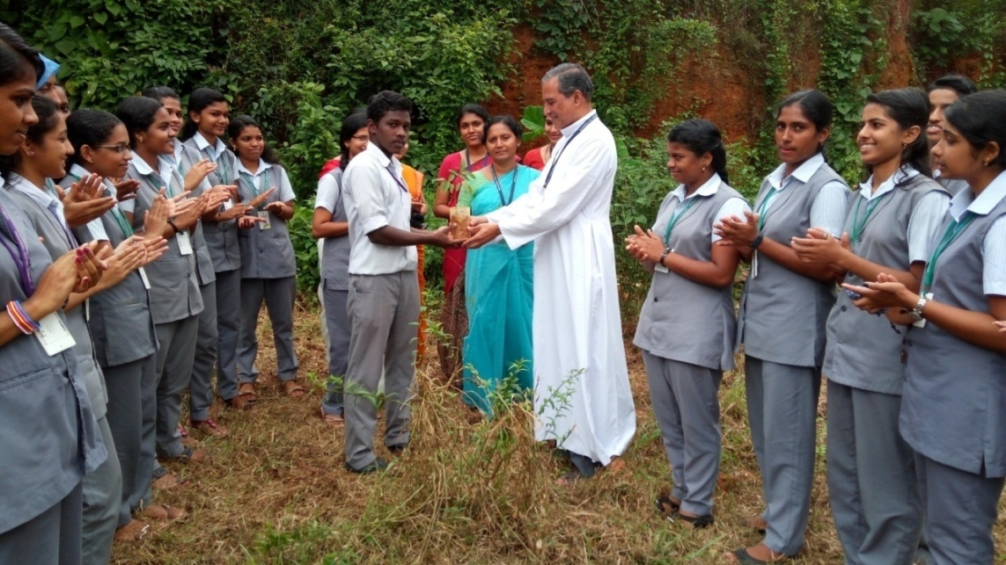

- Planting Trees
Students and teachers planted saplings of flowering plants in the premises to increase the green cover. This was envisaged to convey the message to people that trees are the only practical solution to fight global warming and climate change.
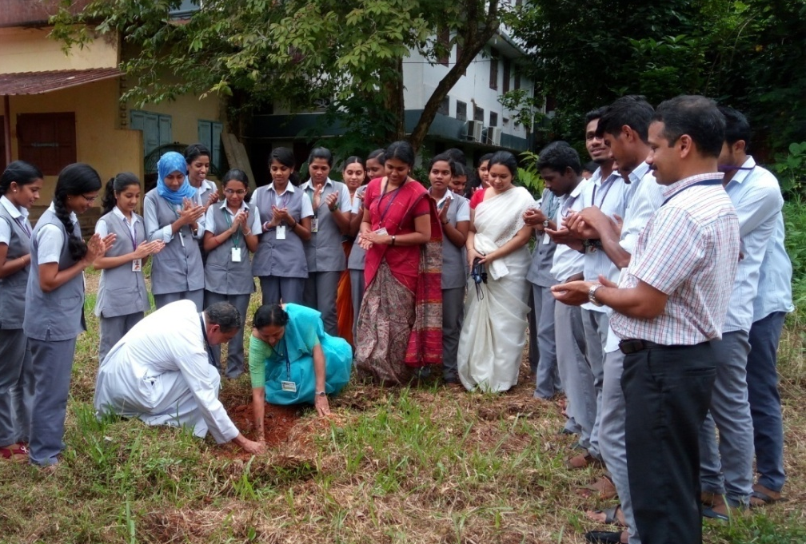

- KSCSTE Sponsored Seminar on ‘Ecologically Sensitive Areas of Western Ghats’
On June 15, Thursday a seminar highlighting the ‘Ecologically Sensitive Areas of Western Ghats’was conducted. Dr. Leena John, Head, Department of Botany welcomed the gathering. Rev. Dr. Manuel Pichalakkat, Vice Principal presided over the function. In his presidential address Vice Principal remarkedabout the abundant greenery of Western Ghats that ensures continuing freshness to human beings. Rev. Fr. Thomas Poovathumkal, Bursar, felicitated the function.The session was handled by the renowned Taxonomist and Environmentalist, Dr. Jomy Augustine, Head, Dept. of Botany, St. Thomas College, Pala. The peculiarities of ecologically sensitive areas were explained in the session. He illustrated the spectacular scenery and abundant biodiversity of the Western Ghats through his presentation. He elaborated the common species of plants like Sonerella, Dipterocarpus, Hoya, Impatiens,Osbeckia, Rhododendron, Baccaurea, Memecylonetc. that are unique only to Western Ghats. The seminar provided a platform for the participants to learn about the floral diversity of Western Ghats andthe peculiarities of ecologically sensitive areas.In the open discussion,the keynote speaker reminded the audience that nature conservation is the sole responsibility of those who intake good food, consume fresh water and breath fresh air.Ms. Sindhu Rachel Joy, coordinator of the programme offered vote of thanks.
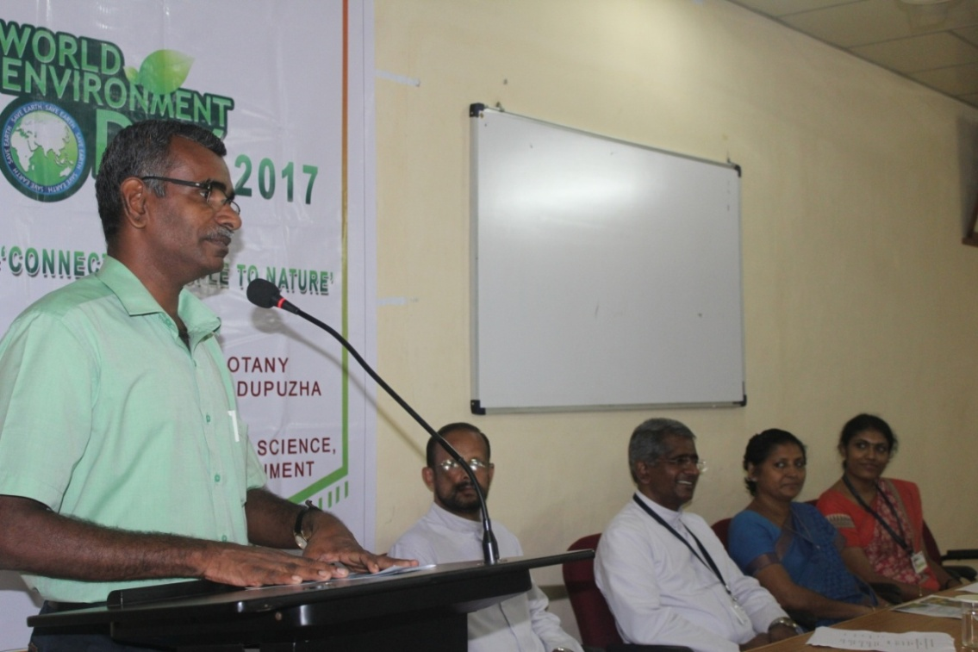
- KSCSTE Sponsored Photo exhibition on ‘Endangered Plants of Kerala’
A Photo exhibitionby Dr. JomyAugustine was also arranged as part of this programme.Rev. Fr. Thomas Poovathumkal, Bursar of our College inaugurated the event. There were plants of Kerala painstakingly captured on lens and taxonomically classified by Dr. JomyAugustine. All the pictures contain brief description and interesting facts about the plants which was highly informative. The photographs of different vegetation types of Kerala were also displayed. The exhibition was opened for staff and students of the college and for public. The enchantingbeauty and diversity of the ephemeral plants created a refreshing experience in the viewers. This event rememorizes the fact that spending time in nature allows our brain to create space for natural creativity to be expressed and even short spurts in nature inspires us to be more creative.
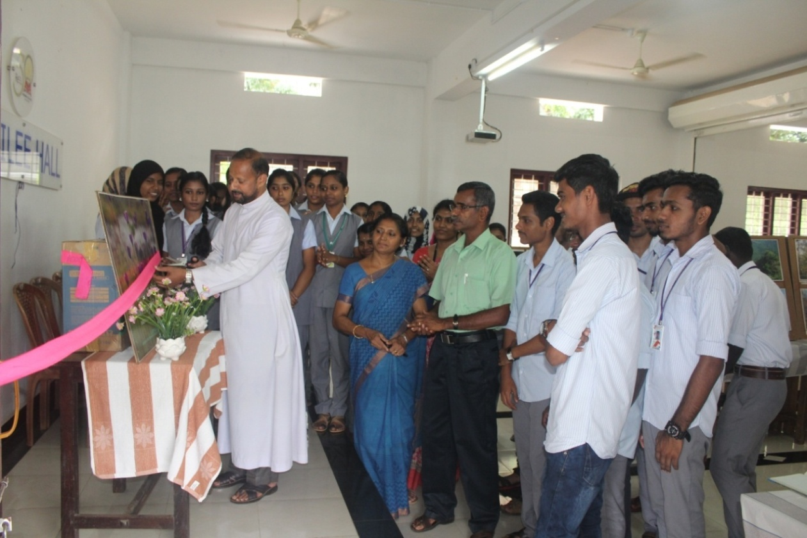

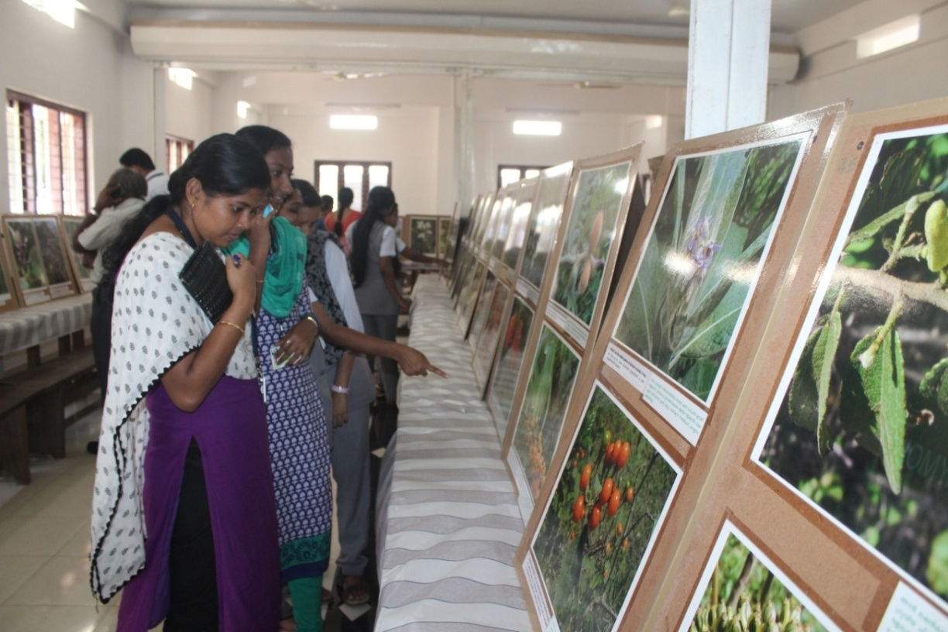

- KSCSTE sponsored Quiz Competition for High School students:
On June 17, Saturday, an environment quiz was conducted for high school students with an intension to create environmental awareness among them. 25 teams from nearby schools participated in this event. The programme started at 9.30 am with the registration of participants. Dr. Saju Abraham, Assistant Professor, Department of Botany was the quiz master. He briefed about the general guidelines of the competition. The competition started with a preliminary written round and 5 teams were selected for the final round. The student participated with great enthusiasm. Jai Rani English Medium School, Thodupuzha, St. Joseph’s H.S.S. Karimanoor, Village International School, Thodupuzha won first, second and third prizes, respectively. Around 160 people participated in this programme including students, parents and teachers. Dr. Saju Abraham and Ms. Sindhu Rachel Joy were the co-ordinators.
A slide show entitled ‘Leave earth a better place to live’ was also presented before the audience. This presentation was based on various aspects like beauty and harmony of nature, nature and its abundant biodiversity, anthropogenic activities like pollution, pesticides, mining, plastic pollution etc. that alter the ecological balance and the retaliation of nature against its abusers in the form of climate change and natural disasters. The presentation disseminated the concept that we have only one planet to live on, it is our home and only we are responsible to maintain its harmony and natural beauty forever.
In the valedictory function, Principal Rev. Dr. Vincent Joseph, awarded cash prizes and certificates to the winners.Dr. Leena John Head, Department of Botany felicitated the function. Dr. Saju Abraham welcomed the gathering and Ms. Sindhu Rachel Joy, coordinator of the programme, offered vote of thanks.

