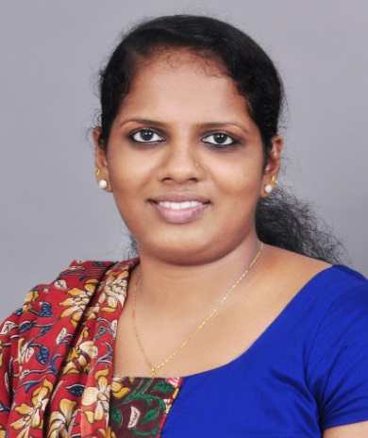 | Name | DIVYA JAMES
 | Designation | Assistant Professor
 | Qualification | M.Com, M.Phil
 | Area of Specialisation | Finance

Educational Qualification
- M.Phil from University of Kerala on the topic ‘ Users’ Perception on Internet Financial Reporting Practices’
- M.Com from Nirmala College, Muvattupuzha

Educational Qualification
- M.Phil from University of Kerala on the topic ‘ Users’ Perception on Internet Financial Reporting Practices’
- M.Com from Nirmala College, Muvattupuzha

Publications
Journals
- Divya James, XBRL: Towards Better Transparency in Internet Financial Reporting, Global Research Review (ISSN 2250-2521), Vol.II No.II-A Dec 2012
- Divya James, Integrated Reporting – A Paradigm shift in Corporate Reporting, Research Scholar (ISSN 2249-6696), Vol. II No IV-A, Dec 2012
- Divya James, Risk Transfer Market: Developments in Exchange-Traded Equity Derivatives in India, Research Lines (ISSN 0975-8941), Vol no.2, Dec 2012
- Divya James, Usage pattern of E-banking services among individuals- with special reference to HDFC and ICICI banks, Rural e- commerce in India – Emerging trends and Challenges (ISBN 978-93-5104-594-6), First edition: 2013
- Divya James, BASEL Accords and its implication on Indian Banks, Misbah ISSN 0976-2523, Book 8 Vol 8, June- Dec 2012

Seminar presentations
International
- Corporate Online Reporting : A Study of listed Companies in India,International Conference on Innovations in Business and Finance, St.Peter’s College, Kolencherry, May 30 – 31 2015
- Corporate Social Responsibility Initiatives: A Study of Listed Indian Companies, International Conference on Innovations in Business and Finance, United Club, Mangalassery, Angamaly, May 23-24, 2014
- Bancassurance - A study on the Potential for Synergy, International Conference on Innovations in Management Practices, Dept. of Management Studies, Kristu Jayanti College, Bangalore, April 20-21, 2012
National
- Usage Pattern of E-banking Services among individuals with Special Reference to HDFC and ICICI Banks, National Seminar on Rural E-Commerce in India: Emerging Trends and Challenges, Post Graduate Dept. of Commerce, Government Arts College, Trivandrum, Mar 15-16 2012
- Advertisement and Buying Behaviour - A Study on LCD Television Consumers, UGC National Conference on Modern Business Practices in Global Scenario, Dept. of Business Administration, Annamali University, Mar 22-23, 2012
- Implication of Basel II on Indian Banks, UGC National Seminar on Financial Sector Reforms and Banking Industry in India, Dept. of Commerce. University of Kerala, Feb 23-24 2012

Awards and Achievements
- Secured Ist rank in the MG University for the M.Com Degree Examination May, 2010
- Awarded Golden Jubilee Gold Medal for the best outgoing student of Nirmala College for the year 2009-10
- Passed UGC National Eligibility Test for Lectureship and Junior Research fellowship, June 2012
- Qualified ICWAI (inter) Stage I Examination conducted by the Institute of Cost and Works Accountants of India
- Passed State Eligibility Test (SET), Sept 2011

Experience
- Teaching experience of 5 months (Jan 4, 2011- Mar 31, 2011) in Marian College, Kuttikkanam, at the Post Graduate level
- Worked as Guest Lecturer in Nirmala College, Muvattupuzha from Nov 1, 2012 to June 2013
- Assistant Professor in Commerce in Newman College, Thodupuzha from 25-06-2013 to present

Participation in Corporate life
- Teacher in charge of

Technical Qualification
- Certificate in ‘Tally Financial Accounting Program’ of the Tally Academy

